INQUIRO
LLM-Powered Multi-Agent Academic Research System: Technical Architecture & System Proposal

Module: | AI Agents — MSc Artificial Intelligence | Date: | June 2026
Version: | 1.0 (Final Team Submission) | Nominated Submitter: | Ramon Flores Arteaga (On behalf of Team)

Executive Summary
Inquiro is a proposed LLM-powered multi-agent system designed to support academic research. The system decomposes research questions into subtasks, retrieves relevant literature, processes findings, and generates structured offline reports. The design combines specialised agents coordinated through LangGraph to improve modularity, transparency, and maintainability.

Literature Review and academic context
Intelligent agents are autonomous systems that perceive their environment and act to achieve goals (Russell and Norvig, 2021). Multi-agent systems distribute responsibilities across specialised agents, improving modularity and maintainability (Wooldridge, 2009). Retrieval-Augmented Generation (RAG) reduces hallucinations by grounding outputs in external knowledge sources (Lewis et al., 2020). ReAct demonstrates the value of combining reasoning and action within LLM-powered systems (Yao et al., 2023).

System requirements and assumptions
Functional Requirements:
- Accept research queries
- Decompose research topics into subtasks
- Retrieve academic information
- Summarise and rank findings
- Generate structured reports
- Store outputs locally
Assumptions:
- Internet connectivity is available
- Academic APIs remain accessible
- Free-tier LLM services are sufficient for a prototype

Design Decisions and Critical Evaluation
LangGraph was selected because it provides explicit state management and deterministic workflows. A multi-agent architecture was selected because specialised agents improve modularity and simplify testing (Wooldridge, 2009).
Since specialised agents improve modularity and simplify testing, a four-agent architecture was selected instead of a single-agent design. In relation to the primary model, Mistral-7B was selected due to its open-source availability, strong instruction-following capability and ability to run locally through Ollama. For the database, arXiv was selected over commercial databases since it provides high-quality academic content without subscription fees. Finally, Jinja2 templates were selected instead of LLM-generated reports because deterministic output improves consistency and reproducibility.

System Architecture & Coordination Topology
The architecture consists of four specialised agents. The Planner Agent uses an LLM to transform a high-level query into structured subtasks. The Retriever Agent searches arXiv and optional web sources. The Processor Agent performs summarisation, ranking and deduplication. The Writer Agent generates a structured markdown report and stores it locally. Agents communicate exclusively through a shared LangGraph state object.
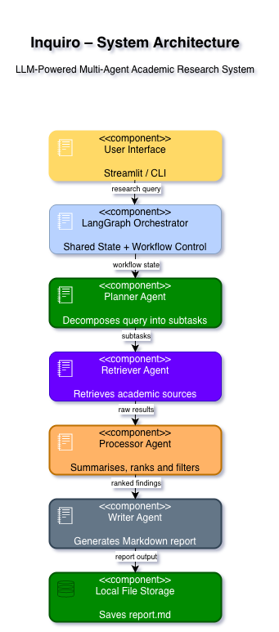

Figure 1 - Inquiro System Architecture: five layers from User Interface to Local Storage

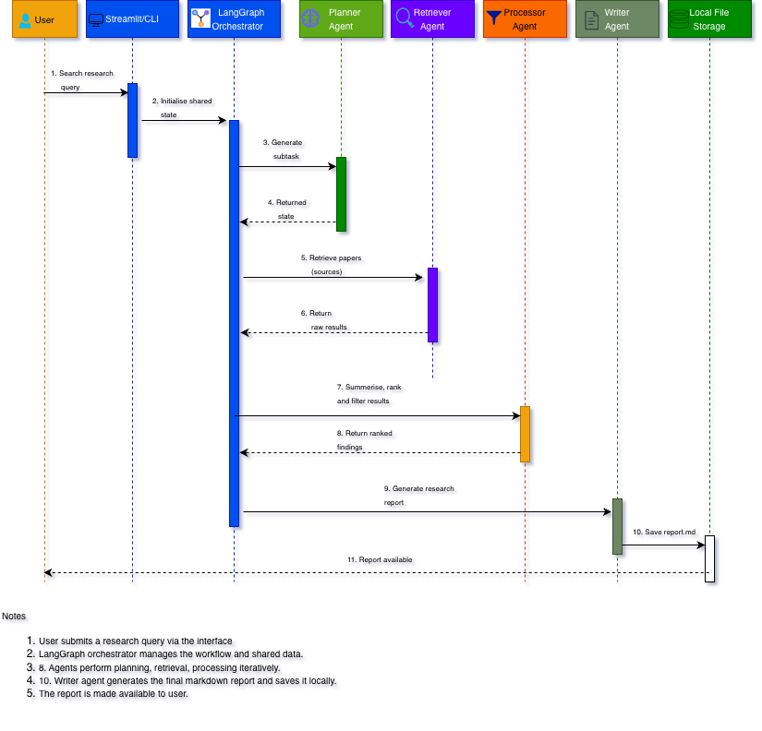
Figure 2 - Inquiro Sequence Diagram: full message flow from query submission to report generation

Architectural Layers & Framework Responsibilities

Table 1 – Architectural Layers & Framework Responsibilities
Execution Layer | Component/Framework | Core Responsibility & Architecture Role
User Interface | Streamlit/CLI (argparse) | Ingests user raw strings; exposes synchronous logging loops and presents final disk paths.
Orchestration | LangGraph System Framework | Maintains state persistence, schema verification, sequential node routing, and edge execution.
Planning Brain | Planner Agent (Mistral-7B) | Leverages LLM structural parsing to divide abstract goals into concrete subtasks.
Data Harvesting | Retriever Agent (arxiv / httpx) | Executes exact API data extraction based on programmatic keyword parameters.
Semantic Reasoning | Processor Agent (Mistral-7B) | Applies context-driven summarization, scoring, and string metrics to filter information noise.
Document Assembly | Writer Agent (Jinja2 / pathlib) | Compiles text vectors using deterministic code templates into final asset formats.
Local Storage | Native File System (pathlib) | Stores outputs offline as Markdown text and JSON historical caches.

Tools, Libraries & Development Environment
To eliminate deployment constraints, Inquiro targets an entirely open-source, zero-cost architecture utilizing localized or free-tier cloud frameworks.
Table 2 – Core stack used for this proposal
Dependency Category | Technology Selected | Target Version | Architecture Purpose & Runtime Context | Cost
Core Runtime Engine | Python Programming Language | 3.11+ | Base execution runtime for graph engines and text parsers. | Free
Orchestration Topology | LangGraph Framework | 0.2.0+ | Stateful graph execution machine; handles state object immutability. | Free/OSS
LLM (cloud) | OpenAI compatible LLM API | Free tier | Model for planning, summarisation, scoring | Free tier
LLM (local) | Ollama | Latest | Local models — no rate limits, no API key | Free / OSS
LLM wrapper | LangChain | 0.3+ | Unified interface for LLM calls | Free / OSS
Paper retrieval | arxiv (pip) | 2.1+ | Python client for the arXiv search API — no API key needed | Free
Web search | duckduckgo-search | 5.0+ | Optional web search for non-academic sources | Free / OSS
HTTP client | httpx | 0.27+ | Async HTTP requests for any additional API calls | Free / OSS
Templating | Jinja2 | 3.1+ | Report template rendering for the Writer Agent output | Free / OSS
UI (optional) | Streamlit | 1.35+ | Simple web UI for submitting queries and viewing progress | Free
Storage | Python pathlib | stdlib | File I/O for saving report.md and JSON cache to disk | Free
Deduplication | Python difflib | stdlib | Fuzzy string matching to remove near-duplicate papers | Free

Data Flow State Schema
from typing import TypedDict, List, Dict, Any
class InquiroState(TypedDict):
query: str # Original user research query
subtasks: List[str] # Parsed decomposition strings from Planner Agent
raw_results: List[Dict] # Unfiltered metadata dictionaries from Retriever
ranked_findings: List[Dict] # Filtered, summarized, and scored paper structures
report_path: str # Final offline disk location reference

Development Methodology
Table 3 – Work methodology by weeks with key deliverables
Week | Milestone | Key deliverables
Week 1 | Setup & design | Roles assigned, Git repo created, shared state schema agreed, 5 test queries defined, LLM confirmed working (local or free OpenAI compatible LLM API)
Week 2 | Agent development | Planner and Retriever agents implemented and unit-tested independently; arXiv results confirmed for 3 test queries
Week 3 | Integration & Processor | Full pipeline wired in LangGraph; Processor Agent summarising and ranking; Writer Agent saving report.md
Week 4 | Evaluation & report | 5 test queries run and results logged; Streamlit UI added; written report and demo prepared for submission

Challenges & Mitigations Strategies
- Hallucinations mitigated through Retrieval-Augmented Generation (Lewis et al., 2020).
- Task decomposition errors reduced through structured prompting.
- Noisy or duplicate results filtered using ranking and deduplication.
- Explainability supported through intermediate agent outputs.
- API failures mitigated through retries, caching, and fallback sources.
- Agent coordination managed through LangGraph state tracking.

Evaluation Strategy
The system will be evaluated using predefined research questions of varying complexity. Metrics include relevance, completeness, coherence, processing time and user satisfaction. Independent evaluation by multiple team members will reduce bias. Success will be measured against the assignment criteria: data retrieval, data processing and offline storage of usable outputs.

Technical Resources
- arXiv (2026) arxiv Python package. Available at: https://pypi.org/project/arxiv/ (Accessed: 4 June 2026)
- DuckDuckGo Search (2026) duckduckgo-search Python package. Available at: https://pypi.org/project/duckduckgo-search/ (Accessed: 4 June 2026).
- Hugging Face (2026) Inference API Documentation. Available at: https://huggingface.co/docs/api-inference/ (Accessed: 4 June 2026).
- Jinja (2026) Jinja2 Documentation. Available at: https://jinja.palletsprojects.com/ (Accessed: 4 June 2026).
- LangChain (2026) LangGraph Documentation. Available at: https://langchain-ai.github.io/langgraph/ (Accessed: 4 June 2026).
- Mistral AI (2026) Mistral-7B-Instruct-v0.2 Model Card. Available at: https://huggingface.co/mistralai/Mistral-7B-Instruct-v0.2 (Accessed: 4 June 2026).
- NVIDIA (2026) NVIDIA NIM LLM APIs Documentation. Available at: https://docs.api.nvidia.com/nim/reference/llm-apis (Accessed: 4 June 2026).
- Ollama (2026) Ollama: Run Large Language Models Locally. Available at: https://ollama.com/ (Accessed: 4 June 2026).
- Streamlit (2026) Streamlit Documentation. Available at: https://streamlit.io/

Conclusion
This proposal has outlined the design of Inquiro, an LLM-powered multi-agent system intended to support academic research and information gathering. The proposed solution uses a Planner Agent, Retriever Agent, Processor Agent and Writer Agent working together to break down research questions, retrieve relevant information, process the results and generate a structured report.
The design was developed using concepts studied throughout the module, including intelligent agents, task decomposition and agent collaboration. A multi-agent approach was selected because it allows different tasks to be separated into smaller, more manageable components, making the system easier to understand and develop.
The proposed technology stack uses freely available tools such as LangGraph, Hugging Face and the arXiv API, making the solution practical to implement within the scope of the project. Although challenges such as retrieval accuracy, explainability and source quality remain, appropriate mitigation strategies have been identified as part of the design.
Overall, the proposed system demonstrates how agent-based approaches and Large Language Models can be combined to support academic research tasks in a structured and practical way.

References & Resources
Table 4 – References & Academic Literature
Academic Reference Identification (APA Seventh Edition) | Engineering Significance & Structural Justification for Inquiro
Wooldridge,M.,2009. An introduction to multiagent systems. John wiley & sons. | A multi-agent architecture was selected because specialised agents can focus on individual tasks while cooperating to achieve a larger objective
Lewis, P., Perez, E., Piktus, A., Petroni, F., Karpukhin, V., Goyal, N., Küttler, H., Lewis, M., Yih, W.T., Rocktäschel, T. and Riedel, S., 2020. Retrieval-augmented generation for knowledge-intensive nlp tasks. Advances in neural information processing systems, 33, pp.9459-9474. | Provides the foundational theory for coupling non-parametric external document indices with parametric language networks to process unstructured data.
Yao, S., Zhao, J., Yu, D., Du, N., Shafran, I., Narasimhan, K. and Cao, Y., 2022. React: Synergizing reasoning and acting in language models. arXiv preprint arXiv:2210.03629. | Informs the interface boundaries of the Planner Agent, outlining how text-based planning sequences interact directly with rule-based environments.
Zhu, Y., Liu, L., Yu, J. and Zhang, D., 2026. LLM-Based Multi-Agent Orchestration: A Survey of Frameworks, Communication Protocols, and Emerging Patterns. | Validates the centralized, graph-driven state architecture choice and substantiates the use of LangGraph for robust, deterministic state machine management.

